Post Details |  | Last Updated: February 2026
Faculty/Administrative/Service Department | Research & Innovation (R&I)
Job Title | Technology Transfer Specialist
Job Family | Professional Services |  | Job Level | Level 4
Responsible to | Managing Director, Innovate Surrey Ltd
Responsible for (Staff) | N/A
Job Purpose Statement

The Technology Transfer Specialist is a key member of the Innovate Surrey Ltd (ISL) team tasked with supporting the delivery of the University’s Vision 2041 goal to be recognised internationally as a hub for game-changing innovation. ISL’s mission is to deliver this goal by supporting the effective translation and commercialisation of university research into impactful technologies and commercial solutions that address key societal challenges.
Working within the ISL team, the postholder will work under the direction of the Managing Director (MD), Innovate Surrey Ltd to identify, protect, manage and commercialise University intellectual property with an emphasis on maximising licensing and spinout opportunities. Alongside the ISL team, the postholder will engage with researchers, external partners and funders to support both the identification of high-potential propositions and the development of commercial opportunities. The postholder will also contribute to the final stages of the commercialisation process and will have exposure to the negotiation of licensing agreements and the formation and follow-on support of spinout companies.
The postholder will work with a wider network of specialist innovation and engagement support teams across the University. The postholder will have the opportunity to learn from experienced colleagues to develop technology transfer skills and experience.
Key Responsibilities This document is not designed to be a list of all tasks undertaken but an outline record of the main responsibilities (5 to 8 maximum)
- Contribute to the identification, protection, management and commercialisation of intellectual property (IP) developed across the University
- Lead the identification of new IP generated through research and undertake prior art, technical and market evaluations to inform decisions on IP protection
- Manage a suitable portfolio of technology transfer projects at different stages in their lifecycle, supporting routes to commercialisation through licensing or spinout activity under the guidance of the MD of ISL, with input from the wider ISL team
- Coordinate and support the work of external legal and patent professionals to manage IP protection and management including assignments, patent filings and prosecutions
- Develop and deliver detailed commercialisation plans for technology transfer projects, working closely with the principal investigators and supporting applications for translational funding
- Contribute to the negotiation, drafting and completion of licence agreements
- Lead the development of spinout business plans and financial projections
Lead the drafting and completion of spinout formation documentation
N.B. The above list is not exhaustive.

All staff are expected to:
- Positively support equality of opportunity and equity of treatment to colleagues and students in accordance with the University of Surrey Equal Opportunities Policy.
- Work to achieve the aims of our Environmental Policy and promote awareness to colleagues and students.
- Follow University/departmental policies and working practices in ensuring that no breaches of information security result from their actions.
- Ensure they are aware of and abide by all relevant University Regulations and Policies relevant to the role.
- Undertake such other duties within the scope of the post as may be requested by your Manager.
- Work supportively with colleagues, operating in a collegiate manner at all times.

Help maintain a safe working environment by:
- Attending training in Health and Safety requirements as necessary, both on appointment and as changes in duties and techniques demand.
- Following local codes of safe working practices and the University of Surrey Health and Safety Policy.
Elements of the Role
This section outlines some of the key elements of the role, which allow this role to be evaluated within the University’s structure. It provides an overview of what is expected from the post holder in the day-to-day operation of the role.
Planning and Organising
- Success in this role is reliant on building strong, successful relationships with researchers and professional services, nurturing an awareness of the benefits of commercialisation and impact across the University
- The postholder is expected to keep up to date with the research activities of staff and to identify a pipeline of high-potential propositions arising from the research outputs. They are required to assimilate the key technical, commercial and societal advantages of any new technology, conduct market analyses to assess the value and potential for exploitation and to assist academic staff in obtaining translational funding to further the project.
- For technologies identified as having possible significant commercial (or non-commercial) impact, the postholder will assess the opportunity, provide support to ensure the IP is identified and where necessary protected, and plan and support the route to commercialisation. The postholder will support the drafting and negotiation of heads of terms agreements and support the completion of agreements. The postholder will be involved in engaging with consultants and conducting or commissioning market research.

Problem Solving and Decision Making.
- Good analytical, problem solving and decision-making skills, and sound judgement are essential to the role. With the support of the wider ISL team, the postholder is expected to support the resolution of problems or issues by identifying key components and generating solutions that produce acceptable and timely outcomes.
- The ideal candidate will be a confident, effective, and empathetic communicator who can work closely with academic inventors to present technologies and solutions effectively to investors, customers and partners.
Continuous Improvement
- The postholder will be required to maintain an up to date understanding of developments in science, technologies, CreaTech and markets relevant to the University’s key research and innovation areas. They will be required to support academics in identifying high-potential propositions and sources of translational funding as well as the subsequent development of commercial opportunities
Accountability
- The postholder will work with a degree of autonomy and therefore, accountable for the quality and professionalism of the services provided.

Dimensions of the role
- Although it is essential that the postholder has technical knowledge related to their aligned discipline or innovation specialism, they may be required to assume responsibilities for other technologies outside their area of speciality from time to time. In addition, business and commercial acumen, marketing and good interpersonal skills are important to be successful in the role.
Supplementary Information
As the structure of ISL evolves, the post holder may be offered the opportunity to manage interns

Person Specification This section describes the sum total of knowledge, experience & competence required by the post holder that is necessary for standard acceptable performance in carrying out this role.
Degree, HND, NVQ 4 qualified or equivalent in relevant subject/relevant formal training, plus a number of years' experience in similar or related roles.  Or:  Significant vocational experience, demonstrating development through involvement in a series of progressively more demanding relevant work/roles, and the acquisition of appropriate professional or specialist knowledge |  |  |  |  | E
Member of a wide network of professional interest groups |  |  |  |  | D
Post-graduate qualification in a relevant subject (ie science, engineering, createch or other innovation-facing discipline) |  |  |  |  | D
Technical Competencies (Experience and Knowledge) This section contains the level of competency required to carry out the role (please refer to the Competency Framework for clarification where needed and the Job Matching Guidance). |  |  |  | Essential/  Desirable | Level  1-3
Project management skills and ability to manage multiple concurrent projects and to work effectively in diverse teams |  |  |  | E | 3
Strong interpersonal and influencing skills with the ability to work collaboratively across internal and external stakeholders |  |  |  | E | 3
Experience of developing business plans and financial forecasts |  |  |  | E | 2
Experience of developing translation and commercialisation plans for technologies |  |  |  | E | 2
Knowledge of commercialisation processes and systems |  |  |  | E | 1
Experience of negotiating commercial and legal agreements |  |  |  | E | 2
Knowledge of IP protection, patenting and IP management |  |  |  | E | 3
Commercial awareness and the ability to undertake IP and market evaluations in technology-based industries |  |  |  | E | 3
Previous experience in technology transfer within a research or commercial environment |  |  |  | D | n/a
Special Requirements: |  |  |  |  | Essential/  Desirable
Must be prepared to travel and work outside normal hours when required |  |  |  |  | E
Core Competencies This section contains the level of competency required to carry out this role. (Please refer to the competency framework for clarification where needed). n/a (not applicable) should be placed, where the competency is not a requirement of the grade. |  |  |  |  | Level  1-3
Communication  Adaptability / Flexibility  Customer/Client service and support  Planning and Organising  Continuous Improvement  Problem Solving and Decision-Making Skills  Managing and Developing Performance  Creative and Analytical Thinking  Influencing, Persuasion and Negotiation Skills  Strategic Thinking & Leadership |  |  |  |  | 3  3  3  3  2  3  n/a  3  3  3
This Job Purpose reflects the core activities of the post. As ISL and the post holder develop, there will inevitably be some changes to the duties for which the post is responsible, and possibly to the emphasis of the post itself. The University expects that the post holder will recognise this and will adopt a flexible approach to work. This could include undertaking relevant training where necessary.

Should significant changes to the Job Purpose become necessary, the post holder will be consulted and the changes reflected in a revised Job Purpose.
Organisational/Departmental Information & Key Relationships

Background Information

ISL is part of the PVCRI portfolio and focuses on delivering impact at scale from the translation and commercialisation of University research outputs.

Department Structure Chart

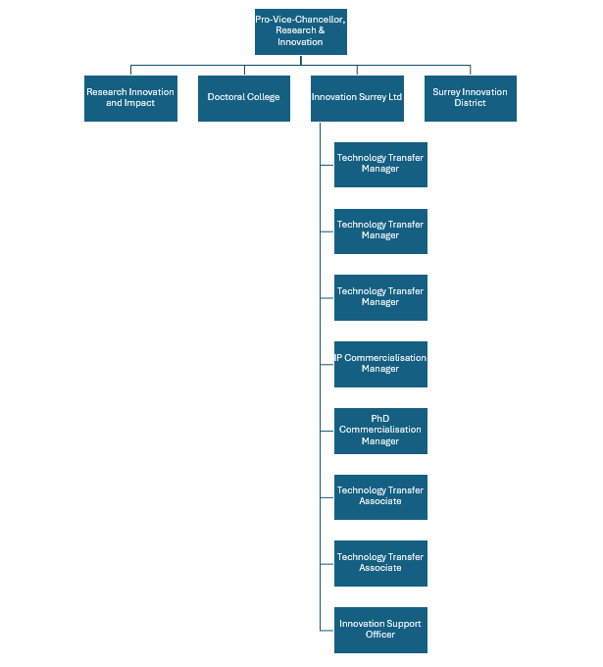

Relationships
Contacts include:
Internal
- ISL team
- Researchers
- Research and Innovation Office colleagues
- Research Innovation and Impact colleagues
- Surrey Innovation District colleagues
- Faculty Impact Champions
- Innovation & Impact Accelerator Managers
External
- Businesses
- UKRI including EPSRC, STFC, Innovate UK and other Government funding bodies
- Knowledge Transfer Network and Catapults
- Other External funders
- Senior managers in HEIF partner Universities
- SETsquared personnel
- Board members of external industrial and commercial partners
- University spin-out companies
- Patent Attorneys
- Consultants
- Market researchers

